Experiencing Music 2200
Music Theory Quiz Review

What You Need to Know…………..
Note Reading
- All notes on the bass clef
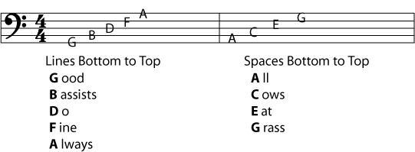
- All notes on the treble clef
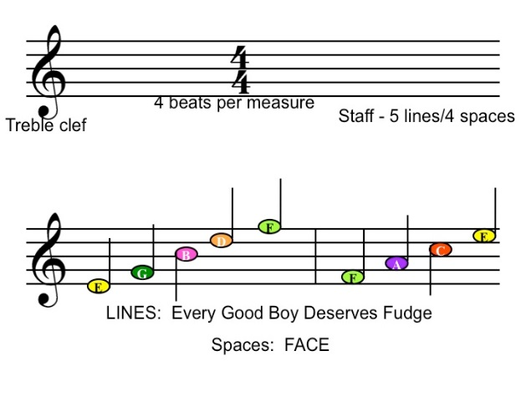
Note and Rest Rhythms
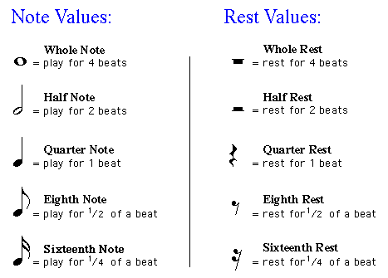

Time Signatures
- 2/4, 3/4, and 4/4
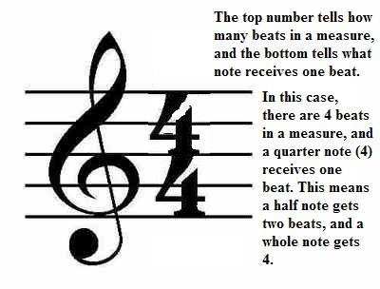

Symbols
- Treble clef
- Bass clef
- Flat
- Sharp
- Forte
- Piano
- Repeat

