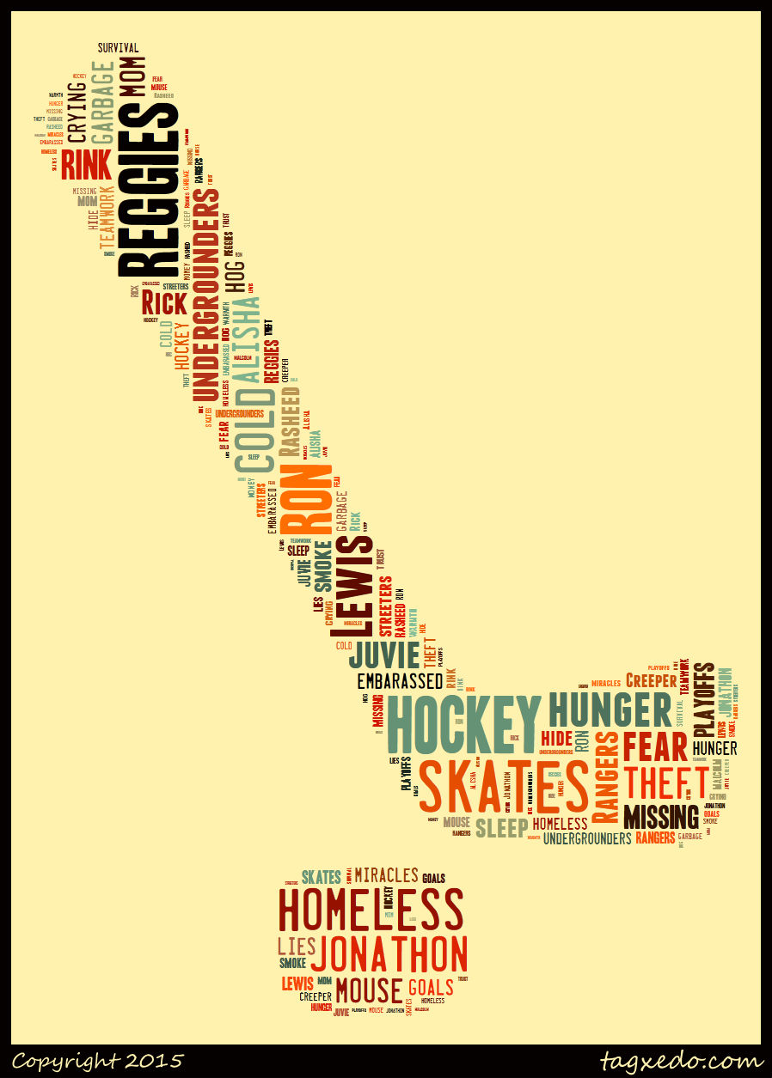
English 3202

Name: _____________________
The Undergrounders Wordle Project
Directions: Choose 15 words from the wordle. Relate each to the novel in two ways. Write about anything including plot, character, setting, symbols, etc.
Word 1: ________________________
____________________________________________________________________________________________________________________________________________________________________________________________________________________________________________________________________________________________________________________________________________________

Word 2: ________________________
____________________________________________________________________________________________________________________________________________________________________________________________________________________________________________________________________________________________________________________________________________________

Word 3: ________________________
____________________________________________________________________________________________________________________________________________________________________________________________________________________________________________________________________________________________________________________________________________________

Word 4: ________________________
____________________________________________________________________________________________________________________________________________________________________________________________________________________________________________________________________________________________________________________________________________________

Word 5: ________________________
____________________________________________________________________________________________________________________________________________________________________________________________________________________________________________________________________________________________________________________________________________________

Word 6: ________________________
____________________________________________________________________________________________________________________________________________________________________________________________________________________________________________________________________________________________________________________________________________________

Word 7: ________________________
____________________________________________________________________________________________________________________________________________________________________________________________________________________________________________________________________________________________________________________________________________________

Word 8: ________________________
____________________________________________________________________________________________________________________________________________________________________________________________________________________________________________________________________________________________________________________________________________________

Word 9: ________________________
____________________________________________________________________________________________________________________________________________________________________________________________________________________________________________________________________________________________________________________________________________________

Word 10: ________________________
____________________________________________________________________________________________________________________________________________________________________________________________________________________________________________________________________________________________________________________________________________________

Word 11: ________________________
____________________________________________________________________________________________________________________________________________________________________________________________________________________________________________________________________________________________________________________________________________________
Word 12: ________________________
____________________________________________________________________________________________________________________________________________________________________________________________________________________________________________________________________________________________________________________________________________________

Word 13: ________________________
____________________________________________________________________________________________________________________________________________________________________________________________________________________________________________________________________________________________________________________________________________________

Word 14: ________________________
____________________________________________________________________________________________________________________________________________________________________________________________________________________________________________________________________________________________________________________________________________________

Word 15: ________________________
____________________________________________________________________________________________________________________________________________________________________________________________________________________________________________________________________________________________________________________________________________________

